SECURE FILE STORAGE SYSTEM WITH ENCRYPTION AND ROLE-BASED ACCESS CONTROL (RBAC)
Conclusion, Future Scope and References
Department of Computer Science and Engineering, TKR College of Engineering & Technology
Batch C13 (CSE-C) · Academic year [ACADEMIC YEAR]
Table 1: Project team
S.No. | Student name | Roll number
1 | Pramod Reddy Yalala | 23K91A05J9
2 | Pendela Vyshnavi | 23K91A05J1
3 | Luke Abraham Sam | 23K91A05D4
4 | Mudavath Suresh | 23K91A05G2

Project guide: D V V Deepthi
Chapter and section numbers quoted in the text (for example Chapter 8 or Section 6.2) refer to the full project report, 17.Final Document. Figures and tables in this document are numbered from 1.

1. CONCLUSION

1.1 Summary
CipherVault is a working secure file store in which the browser encrypts every file before upload, the server stores only ciphertext and enforces Owner, Editor and Viewer roles, and every sensitive action is written to a hash-chained audit log. It was built with FastAPI, SQLAlchemy, React and the Web Crypto API, and measured on one 12th Gen Intel Core i5-12500 (6 cores / 12 threads) desktop. The honest outcome is positive on confidentiality, integrity and access control, and mixed on the audit trail, whose limits were found by the project's own tamper study.

1.2 Objectives against outcomes
Table 2: Objectives against outcomes
Objective | Outcome | Evidence
1 Registration and authentication with hashed credentials and JWT sessions | Achieved | bcrypt cost 12, HS256 tokens with 120-minute expiry; login median 308 ms; forged, expired, wrong-secret and alg=none tokens all rejected
2 Encrypt every file with AES-256-GCM before it reaches storage | Achieved | Encryption in the browser; the stored object is ciphertext; 2,000 of 2,000 bit flips rejected; limited to 25 MB per file
3 Role-based access with ownership checks | Achieved | 36 of 36 role-matrix cells as expected; revocation stops downloads (403) but does not recall keys
4 Integrity verification on download | Achieved | AES-GCM tag plus SHA-256 of the plaintext; a wrong key or altered ciphertext is rejected
5 Audit logs of uploads, downloads, deletes and denials | Achieved with defects | All four event kinds logged in a hash chain with a verification screen; tail truncation (0 of 199) and concurrent writers are not handled
6 Evaluate overhead, access-control correctness and integrity | Achieved within limits | Chrome and API measurements, exhaustive role matrix and tamper study; one shared machine, no user study; 21 pytest, 17 API and 18 UI checks passed

1.3 Key findings
1. Encryption in the browser costs little. AES-256-GCM encrypts 25 MiB in a median 53.8 ms and decrypts it in 50.9 ms; for a 10 MiB file the whole encrypted upload takes a median 209 ms against 194 ms for a plain upload (p95 352 ms), a difference that is within the run-to-run spread of the shared machine. Key generation, once per account, takes 102 ms.
2. The access rules held in every checked case. All 36 cells of the role matrix behaved as intended, unauthenticated requests (5 of 5) and four kinds of forged token were refused, and a download after revocation returned HTTP 403. This is exhaustive over the implemented operations, not a user study.
3. Integrity is enforced twice. All 2,000 of 2,000 single-bit changes to stored ciphertext were rejected by the AES-GCM tag, and a wrong key failed to decrypt; the browser additionally refuses to save a file whose SHA-256 does not match.
4. The audit chain catches edits but not removal or rewriting. Eight of nine tamper classes were caught in all 1,599 trials, tail truncation in 0 of 199, and a rewrite that recomputes later hashes was not detected. 100 concurrent failed logins forked the chain (first bad entry 5,047 of 5,145). A writer lock and an external anchor are required.
5. Costs sit in the slow-by-design steps. A sign-in takes a median 308 ms because of bcrypt and unlocking the vault 32.8 ms for PBKDF2, while an authenticated me call takes 6.32 ms; verifying 5,000 audit entries takes 404 ms and grows linearly.
6. The trust boundary is the delivered code and the password. The server never sees plaintext or a usable key in normal operation, but it serves the JavaScript that does the cryptography and receives the password that protects the key bundle; revocation cannot recall what a recipient already holds.
The abstract's statement that the system can later be extended to cloud storage and professional key management is a statement of future scope; it is not demonstrated here. The same holds for PostgreSQL, which is supported by configuration but was not exercised.

1.4 Closing remark
The value of the project is a runnable, measured design and a precise list of what to repair. With a writer lock and an external anchor for the audit chain, a separate secret for key derivation, re-keying on revocation and chunked encryption for large files, the same code would be a sound base for a small organisation's confidential document store.
The measurements behind the key findings are shown below: the access-control matrix, where every one of the 36 cells matched, and the tamper study, where eight of nine audit-log tampering classes were detected and tail truncation was not. The base paper reports calculated primitive costs on other hardware, so no figure here can be ranked against it.
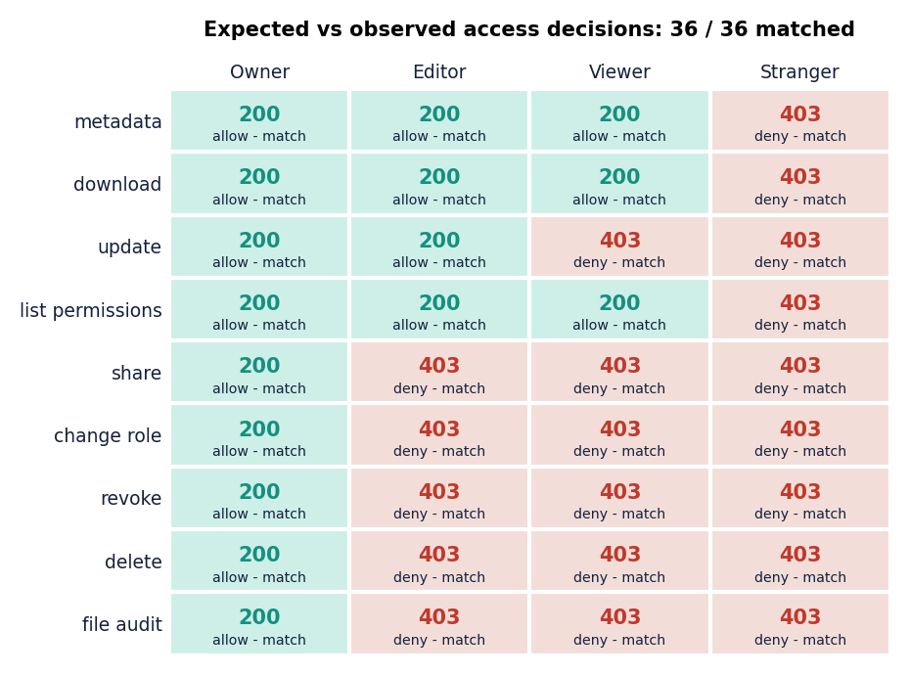
Figure 1: Access-control matrix: four principals against nine operations, expected against observed.
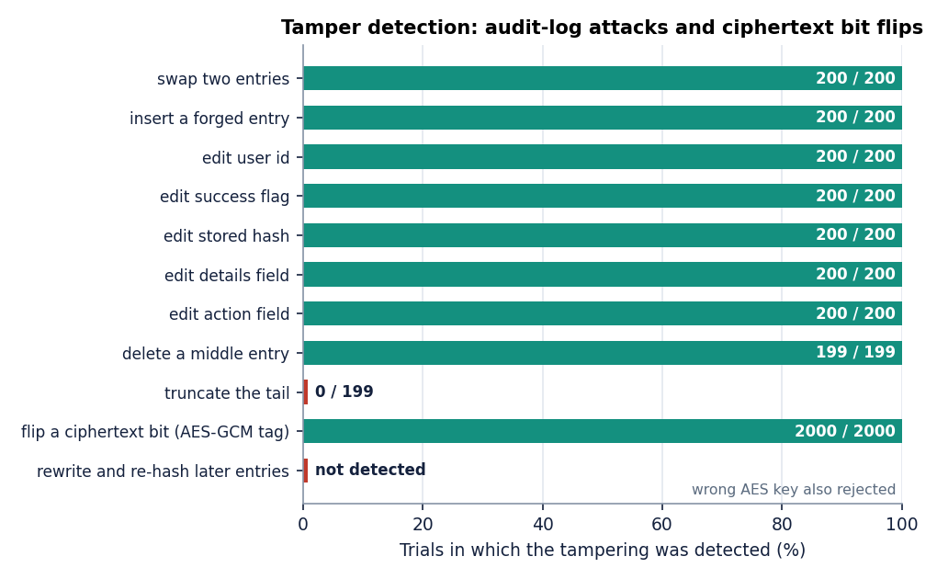
Figure 2: Detection rate of each audit-log tampering class.

2. FUTURE SCOPE

2.1 Repair the weaknesses found
• Make the audit log tamper-evident. Take a lock around reading the last hash and writing the new row (or a single writer queue), sign each entry or the chain head with a server-held HMAC key, and publish the head to a separate place so that truncation and consistent rewriting become detectable [31], [32]. Rerun the 199-trial truncation test and the 100-login concurrency test.
• Restrict the audit list. Return only the caller's own events from GET /api/audit, and let the owner of a file see that file's events.
• Separate the two secrets. Derive an authentication value in the browser (or use an augmented password protocol) so the server never receives the password that unlocks the key bundle.
• Strengthen key derivation. Raise PBKDF2 to at least the 310,000 iterations used by the IJEDR paper [2], or switch to a memory-hard function such as Argon2id.

2.2 Close the design gaps
• Re-key on revoke. Generate a new file key, re-encrypt the file and re-wrap for the remaining users, so a revoked user's saved key no longer opens new content.
• Chunked, streaming encryption with per-chunk authentication, so that files above 25 MB can be handled without holding them in memory.
• Multi-factor sign-in (TOTP), as in the closest related paper, and account recovery by an optional recovery key.
• Key transparency. Show a fingerprint of a recipient's public key and let users compare it out of band, so a substituted key is noticed.
• Content-security policy and subresource integrity to narrow the problem of a server that serves the cryptographic code [8].

2.3 Scale and deploy
• S3-compatible object storage behind the existing storage module, and a key-management service or hardware security module for server-side secrets such as the JWT signing key.
• PostgreSQL in continuous integration, so the path that the abstract names is tested on every change.
• Measurement under many simultaneous users, with the audit writes moved to a queue.

2.4 Evaluate with people
• A usability study of the unlock, share and revoke flows, and an independent penetration test and code review.
• A comparison with an attribute-based design on the same files, using the same measured, end-to-end method rather than calculated primitive costs [1], [19].
The order matters: the repairs in the first group are small and testable, and they should be done before new features, because every later stage builds on an audit trail and a key hierarchy that can be trusted.
Table 3: Roadmap
Stage | Work | Done when
1. Repair what was measured | Writer lock and an externally anchored or HMAC-signed chain head; restrict GET /api/audit to own events; separate the sign-in secret from the key-derivation secret; PBKDF2 at 310,000 iterations or Argon2id | The 200-trial truncation test and the 100-login concurrency test both report a valid, detecting chain
2. Close the design gaps | Re-key on revoke; chunked streaming encryption beyond 25 MB; MFA; content-security policy and subresource integrity; out-of-band public-key fingerprints | A revoked user's saved key no longer opens new content; a 200 MB file uploads
3. Scale and deploy | S3-compatible object storage, a key-management service, PostgreSQL in continuous integration, a queue for audit writes | The Docker composition passes the same suite on PostgreSQL
4. Evaluate with people | A usability study and an independent security review | Task success rates and review findings are in the report

3. REFERENCES
[1] A. Nekouie, M. Vafaei Jahan, M. H. Moattar and R. Sheibani, "Secure electronic health record access control via blockchain, dual-attribute encryption, and large language model-based attribute extraction," Scientific Reports, vol. 16, art. no. 8673, 2026, doi: 10.1038/s41598-026-39690-2.
[2] G. Sowmiya, R. Nivas and E. Vikram, "Secure cloud file storage architecture with client-side encryption and access control," Int. J. Eng. Develop. Res. (IJEDR), vol. 14, no. 2, pp. 576-579, Apr. 2026, paper IJEDR2602501.
[3] "Secure file storage on cloud using AES encryption," Int. Res. J. Modernization in Engineering, Technology and Science (IRJMETS), 2026 (title as listed in the batch literature survey; not located online and not quoted).
[4] "Secure cloud-based file storage system with enhanced data integrity and access control," in Proc. 6th Int. Conf. Pervasive Computing and Social Networking (ICPCSN), 2026 (title as listed in the batch literature survey; not located online and not quoted).
[5] "An integrated image encryption and secure transmission scheme for cloud environments using chaotic mapping and cryptographic access control," 2026 (title as listed in the batch literature survey; not located online and not quoted).
[6] P. Thenmozhi, V. D. Saralesh and R. Sakthi, "Geocrypt: Location-based secure file encryption and access control," ITM Web of Conferences, vol. 82, art. no. 03019, 2026, doi: 10.1051/itmconf/20268203019.
[7] E. Saginayev, A. Niyazov, A. Razaque, Zh. Kalpeyeva and A. Urazgaliyeva, "Secure file storage on cloud using hybrid cryptography," Computing & Engineering, vol. 2, no. 2, pp. 1-7, 2024, doi: 10.51301/ce.2024.i2.01.
[8] M. Backendal, M. Haller and K. G. Paterson, "MEGA: Malleable encryption goes awry," in Proc. IEEE Symp. Security and Privacy (SP), 2023, pp. 146-163.
[9] H. Bock, A. Zauner, S. Devlin, J. Somorovsky and P. Jovanovic, "Nonce-disrespecting adversaries: Practical forgery attacks on GCM in TLS," in Proc. 10th USENIX Workshop on Offensive Technologies (WOOT), Austin, TX, USA, Aug. 2016.
[10] E.-J. Goh, H. Shacham, N. Modadugu and D. Boneh, "SiRiUS: Securing remote untrusted storage," in Proc. Network and Distributed System Security Symp. (NDSS), 2003.
[11] M. Kallahalla, E. Riedel, R. Swaminathan, Q. Wang and K. Fu, "Plutus: Scalable secure file sharing on untrusted storage," in Proc. 2nd USENIX Conf. File and Storage Technologies (FAST), San Francisco, CA, USA, 2003, pp. 29-42.
[12] Z. Wilcox-O'Hearn and B. Warner, "Tahoe: The least-authority filesystem," in Proc. 4th ACM Int. Workshop on Storage Security and Survivability (StorageSS), 2008, pp. 21-26, doi: 10.1145/1456469.1456474.
[13] R. A. Popa, C. M. S. Redfield, N. Zeldovich and H. Balakrishnan, "CryptDB: Protecting confidentiality with encrypted query processing," in Proc. 23rd ACM Symp. Operating Systems Principles (SOSP), 2011, pp. 85-100, doi: 10.1145/2043556.2043566.
[14] S. Kamara and K. Lauter, "Cryptographic cloud storage," in Financial Cryptography and Data Security Workshops 2010, Lecture Notes in Computer Science, vol. 6054, Springer, 2010, pp. 136-149.
[15] D. F. Ferraiolo, R. Sandhu, S. Gavrila, D. R. Kuhn and R. Chandramouli, "Proposed NIST standard for role-based access control," ACM Trans. Inf. Syst. Secur., vol. 4, no. 3, pp. 224-274, Aug. 2001, doi: 10.1145/501978.501980.
[16] R. S. Sandhu, E. J. Coyne, H. L. Feinstein and C. E. Youman, "Role-based access control models," IEEE Computer, vol. 29, no. 2, pp. 38-47, Feb. 1996.
[17] J. H. Saltzer and M. D. Schroeder, "The protection of information in computer systems," Proc. IEEE, vol. 63, no. 9, pp. 1278-1308, Sep. 1975.
[18] V. Goyal, O. Pandey, A. Sahai and B. Waters, "Attribute-based encryption for fine-grained access control of encrypted data," in Proc. 13th ACM Conf. Computer and Communications Security (CCS), 2006, pp. 89-98, doi: 10.1145/1180405.1180418.
[19] J. Bethencourt, A. Sahai and B. Waters, "Ciphertext-policy attribute-based encryption," in Proc. IEEE Symp. Security and Privacy (SP), 2007, pp. 321-334, doi: 10.1109/SP.2007.11.
[20] G. Ateniese, K. Fu, M. Green and S. Hohenberger, "Improved proxy re-encryption schemes with applications to secure distributed storage," ACM Trans. Inf. Syst. Secur., vol. 9, no. 1, pp. 1-30, Feb. 2006, doi: 10.1145/1127345.1127346.
[21] M. Dworkin, "Recommendation for block cipher modes of operation: Galois/Counter Mode (GCM) and GMAC," NIST Special Publication 800-38D, Nov. 2007.
[22] National Institute of Standards and Technology, "Advanced Encryption Standard (AES)," Federal Information Processing Standards Publication 197, Nov. 2001 (updated May 2023).
[23] National Institute of Standards and Technology, "Secure Hash Standard (SHS)," Federal Information Processing Standards Publication 180-4, Aug. 2015.
[24] K. Moriarty, Ed., B. Kaliski, J. Jonsson and A. Rusch, "PKCS #1: RSA cryptography specifications version 2.2," IETF RFC 8017, Nov. 2016.
[25] M. Bellare and P. Rogaway, "Optimal asymmetric encryption," in Advances in Cryptology - EUROCRYPT '94, Lecture Notes in Computer Science, vol. 950, Springer, 1995, pp. 92-111.
[26] K. Moriarty, Ed., B. Kaliski and A. Rusch, "PKCS #5: Password-based cryptography specification version 2.1," IETF RFC 8018, Jan. 2017.
[27] M. S. Turan, E. Barker, W. Burr and L. Chen, "Recommendation for password-based key derivation, part 1: Storage applications," NIST Special Publication 800-132, Dec. 2010.
[28] N. Provos and D. Mazieres, "A future-adaptable password scheme," in Proc. USENIX Annual Technical Conf., Monterey, CA, USA, Jun. 1999, pp. 81-92.
[29] M. Jones, J. Bradley and N. Sakimura, "JSON Web Token (JWT)," IETF RFC 7519, May 2015.
[30] M. Watson, Ed., "Web Cryptography API," W3C Recommendation, Jan. 26, 2017. [Online]. Available: https://www.w3.org/TR/2017/REC-WebCryptoAPI-20170126/
[31] B. Schneier and J. Kelsey, "Secure audit logs to support computer forensics," ACM Trans. Inf. Syst. Secur., vol. 2, no. 2, pp. 159-176, May 1999.
[32] S. A. Crosby and D. S. Wallach, "Efficient data structures for tamper-evident logging," in Proc. 18th USENIX Security Symp., Montreal, QC, Canada, Aug. 2009, pp. 317-334.
[33] E. Alsentzer et al., "Publicly available clinical BERT embeddings," in Proc. 2nd Clinical Natural Language Processing Workshop, Minneapolis, MN, USA, Jun. 2019, pp. 72-78, doi: 10.18653/v1/W19-1909.
[34] E. Androulaki et al., "Hyperledger Fabric: A distributed operating system for permissioned blockchains," in Proc. 13th EuroSys Conf., Porto, Portugal, Apr. 2018, doi: 10.1145/3190508.3190538.

